 | IQVIATM Work Instruction Statistical Authorization to Lock a Database
Document Number and Revision:
CS_WI_BS010 Revision 14
Document Owner:  Carrie Eason | Author(s):  R Gunasekaran

PURPOSE
To describe planning, preparation and IQVIA Biostatistics authorization to lock an interim or final clinical study database.

SCOPE

  - Applies to all studies globally where IQVIA Biostatistics uses a locked database (interim or final) to create statistical deliverables.

ROLES AND RESPONSIBILITIES
The following roles perform tasks described within this WI:

Role | Sections
Statistical Team Lead (STL) | 6.1, 6.2, 6.3, 6.4, 6.5
Programming Team Lead (PTL) | 6.2
Biostatistics Project Team Member (BPTM) | 6.2
Data Team Lead (DTL) | 6.2, 6.3

DEFINITIONS
Data Review System: A Data Management tool used by Biostatistics and Data Management for the documentation and communication of data issues identified by Biostatistics.

MATERIAL AND EQUIPMENT
Not Applicable

PROCEDURE
The workflow diagrams for this work instruction are in Section 10.0, Appendices.
The steps involved in the statistical authorization to lock a database (interim or final) are:
- Plan for database lock
- Prepare for database lock
  - Statistical review of the database
  - Statistical review of the Data Handling Report (DHR) or equivalent
- Authorize database lock
- Documentation and archival

  - Plan for Database Lock

Page 1 of 11
Copyright © 1999, 2000, 2003, 2004, 2006, 2008, 2010, 2011, 2013, 2015, 2017, 2019, 2021, 2023 IQVIA. All rights reserved. The
contents of this document are confidential and proprietary to IQVIA Holdings Inc. and its subsidiaries. Unauthorized use, disclosure or reproduction is strictly prohibited.

No: | Who: | Step: | When:
6.1.1 | STL | Participates in database lock planning (final and interim) with the customer, clinical/project leadership and Data Management (DM), in accordance with Database Lock (CS_WI_DM0421), as appropriate.  Note: The timing of database lock preparation activities will be planned with DM per the study requirements and data sources at the DM and Biostatistics Planning Meeting. The DTL may use the Action Management module of IQVIA's business process management tool to distribute the DM and Biostatistics Meeting Agenda.  Note: For an interim analysis, assess the scope of the interim planning (Interim Statistical Analysis Plan, Data Monitoring Committee (DMC) Charter, or equivalent) to determine the extent to which this Work Instruction (WI) is applicable. The interim database  lock must be performed in accordance with an Interim Database Lock Plan (CS_TP_DM0286), if applicable. | Planning for database lock (interim or final)
6.1.2 | STL | Prepares for the authorization of the database by following the steps outlined in this document. Any differences in process or documentation are to be detailed in a Project Instruction, per Applying SOPs and Project Instructions to the Project (CS_WI_PL0022) or documented in the Biostatistics Quality Control (QC) Plan (CS_TP_BS002) if a customer procedure is being followed.  Note: If, per the scope of work, the STL does not have responsibility for authorizing the database lock, the STL consults with the customer and documents agreements and deviations as  mentioned in this step. | Planning for database lock (interim or final)
6.1.3 | STL | Coordinates with the DTL on the timing and frequency of data review and feedback as part of the Database Lock Planning Meetings. The DTL may use the Action Management module of IQVIA's business process management tool to distribute the Data Lock Planning Meeting Agendas (final and interim). | Throughout the conduct of the study
6.1.4 | STL | Considers the following documentation:  - Study protocol  - Annotated Case Report Form  - Statistical Analysis Plan (SAP)  - Interim SAP/DMC Charter, if appropriate  - Biostatistics QC Plan  - Relevant DM Plan documents (see Statistical Review and Authorization of Data Management Plan Documents (CS_WI_BS008))  - Unblinding Plan  - Any relevant Customer communication pertaining to the clinical study database | Preparing for database lock (interim or final)

  - Statistical Review of the Database
The statistical review of the database comprises the acceptance of the data transfer(s), data issue identification, communication and closure, and finalization of the analysis sets (or equivalent).
The use of the Data Issues Log (CS_TP_BS014) to log, communicate and close data issues may be replaced by the Data Review System, for resolution by DM.
A data transfer may be a transfer of data files by IQVIA DM (or vendor) to the Biostatistics project directory and/or the extraction of data files by Biostatistics from a repository, per Handling Data Transfers (CS_WI_BS020).

No: | Who: | Step: | When:
6.2.1 | STL/PTL | Reviews the transfer according to Handling Data Transfers (CS_WI_BS020). | Upon receipt of a data transfer
6.2.2 | STL/PTL | Creates a single, cumulative Data Issues Log for communicating data issues and associated resolutions throughout the study. If multiple Data Issues Logs are used during the study, these must be compiled into one final log prior to authorization.  When using the Data Review System, a worksheet containing the list of data issues is uploaded directly into the Data Review System. | Throughout the conduct of the study
6.2.3 | BPTM | Identifies data issues that need to be resolved or explained and uses the Data Issues Log (CS_TP_BS014) or Data Review System to communicate issues to the DTL.  Note: Data issues are identified by team members on an ongoing basis while performing production, QC and/or review activities according to Derived Datasets (CS_WI_BS013), Statistical Output (CS_WI_BS014), Handling Data Transfers (CS_WI_BS020) and  Submission Deliverables (CS_WI_BS022). | Throughout the conduct of the study
6.2.4 | STL | Reviews the database to determine analysis set assignments and to identify data issues that may affect the proposed statistical analyses and presentations according to Analysis Sets (CS_WI_BS011).  Communicates data issues to the DTL using the Data Issues Log or Data Review System. | Prior to database lock (interim or final)
6.2.5 | STL/PTL | When using the Data Issues Log, makes the log available to the DTL to allow issue resolution prior to clinical study database lock, or interim database lock (if applicable). When using the Data Review System, adds the data issues as agreed with DTL to allow issue resolution prior to clinical study database lock, or interim database lock (if applicable). | Throughout the conduct of the study
6.2.6 | STL/PTL | Collaborates with the DTL to enable appropriate resolution and verification of the data issue queries. | Throughout the conduct of the  study
6.2.7 | DTL | Takes the necessary action, e.g., issue queries to address data issues, and notes the action/resolution/confirmation/approval in the Data Issues Log/ Data Review System. | Throughout the conduct of the study

No: | Who: | Step: | When:
6.2.8 | DTL | Updates the Data Issues Log or Data Review System and notifies the STL/PTL. | Throughout the conduct of the study
6.2.9 | DTL | Requests a new data transfer to Biostatistics or notifies the STL/PTL per Data Transfer (CS_WI_DM0412).  Note: The new data transfer may correspond with the next planned data transfer. | The data issues have been resolved, corrected and/or explained
6.2.10 | STL/PTL | Reviews the Data Issues Log/ Data Review System against the data cleaning requirements outlined in the Interim Database Lock Plan (CS_TP_DM0286) and requests resolution of outstanding items prior to noting database acceptance in the Data Issues Log. | Prior to interim database lock
6.2.11 | STL | Requests all team members involved in the database review, data issues identification and resolution activities to sign the Data Issues Log or provide comments in the Data Review System to confirm closure of data queries. | When no unresolved queries remain in the Data Issues Log/ Data Review System (interim or  final lock)
The steps in Section 6.2 are repeated until there are no unresolved items in the Data Issues Log/ Data Review System. Unresolvable data issues are listed in the DHR (or equivalent document).

  - Statistical Review of the Data Handling Report
Statistical review of the Data Handling Report is required as per Data Handling Report (CS_WI_DM0413) for databases (interim or final) transferred to Biostatistics by IQVIA DM. For non-IQVIA DM studies, review an equivalent document or follow the process agreed during database lock planning.
The review of items compiled into the IQVIA DM DHR may occur using Data Handling Database (DHD) functionality within IQVIA's business process management tool. Individual Data Handling Entries (DHE) in the DHD are reviewed on an ongoing basis during the conduct of a study. The DHR is a cummulative report from the DHD and is reviewed before an interim or final clinical study database lock and routine treatment unblinding.

No: | Who: | Step: | When:
6.3.1 | STL | For studies where IQVIA DM is contracted, reviews the DHR, or equivalent, when provided by the DTL. For non-IQVIA DM studies,  reviews the equivalent document or follows the process agreed in the database lock planning. | Prior to database lock or interim database lock
6.3.2 | STL | Considers the following items in the DHR as they may impact the statistical analyses:  - Medical terms (e.g., adverse events, concomitant medications) which could not be coded using medical dictionaries. | During data review to determine analysis set assignments and identify data

No: | Who: | Step: | When:
 |  | - Data conventions used during the study, and any deviations from these conventions.  - Unresolved data issues including:  - unresolved queries,  - general comments on the quality of the data or exceptional data,  - additional information captured but not part of the clinical study database.  - All data issues that might affect analysis or reporting of data.  - Appropriate identification of any subjects who changed site during the study so that all data can be correctly attributed.  Note: The focus of the review of the DHR is identification of items that may affect the critical data items identified during the review of the Edit Checks (see Statistical Review and Authorization of Data Management Plan Documents (CS_WI_BS008)). | issues that may affect the planned analyses
6.3.3 | STL | Identifies any data or data handling issues noted in the DHR to be resolved for conducting the statistical analysis, or similar purposes. | When reviewing the DHR
6.3.4 | STL | Communicates the identified issues to the DTL for resolution using the Data Issues Log or Data Review System. | Before final study database lock, or interim database lock (if applicable)
6.3.5 | STL | Collaborates with the DTL to ensure appropriate resolution and verification of the issues identified during the review of the DHR. | Prior to final database lock, or interim database lock (if applicable)
6.3.6 | DTL | Verifies appropriate resolution and verification of the issues identified during the review of the DHR. | Prior to final database lock, or interim database  lock (if applicable)
The steps in Section 6.3 are repeated until there are no unresolved items in the Data Issues Log/ Data Review System or Data Handling Report (or equivalent document).

  - Authorization to Lock a Clinical Study Database
The statistical review of the database and DHR must be complete prior to the authorization of an interim or final database lock. All data issues identified by the statistical review must be resolved or documented as unresolved in the DHR prior to authorization of lock.
It is not expected that the interim or final clinical study database is 100% issue free. The STL must consider the impact of any unresolved issues on key analyses to determine whether the database is suitable for analysis with those issues left unresolved.

No: | Who: | Step: | When:
6.4.1 | STL | Authorizes the locking of the interim clinical study database by signing the Interim Database Lock Form (CS_FM_DM0427) or the final clinical study database by signing the Database Lock Form (CS_FM_DM002). | After completion of the statistical review of the database and DHR, the resolution of issues and authorization of the Data Issues Log
6.4.2 | STL | Authorizes unlocking/re-locking of the clinical study database (or interim database lock) utilizing the same process as described above. | If a database unlock/relock is required or interim  database unlock

  - Documentation and Archival

No: | Who: | Step: | When:
6.5.1 | STL | Files the authorized final Data Issues Log or the export of Biostatistics identified data issues from the Data Review System in the eTMF according to the TMF platform used per Trial Master File  (TMF) (CS_OP_TMF0007) and Management and Filing of Biostatistics Documentation (CS_WI_BS0237). | After the final, locked database is accepted
6.5.2 | STL | Archives all documentation necessary for the reproduction of the  output delivered to the Customer, according to Management and Filing of Biostatistics Documentation (CS_WI_BS0237). | After finalization of statistical deliverables

- SUPPORTING DOCUMENTATION
DOCUMENT NUMBER | TITLE
ESOP References
7.1 CS_FM_DM002 | Database Lock Form
7.2 CS_FM_DM0427 | Interim Database Lock Form
7.3 CS_OP_TMF0007 | Trial Master File (TMF)
7.4 CS_TP_BS002 | Biostatistics QC Plan
7.5 CS_TP_BS014 | Data Issues Log
7.6 CS_TP_DM0286 | Interim Database Lock Plan
7.7 CS_WI_BS008 | Statistical Review and Authorization of Data Management Plan Documents
7.8 CS_WI_BS011 | Analysis Sets
7.9 CS_WI_BS013 | Derived Datasets
7.10 CS_WI_BS014 | Statistical Output
7.11 CS_WI_BS020 | Handling Data Transfers

DOCUMENT NUMBER | TITLE
7.12 CS_WI_BS022 | Submission Deliverables
7.13 CS_WI_BS0237 | Management and Filing of Biostatistics Deliveries and Documentation
7.14 CS_WI_DM0412 | Data Transfer
7.15 CS_WI_DM0413 | Data Handling Report
7.16 CS_WI_DM0421 | Database Lock
7.17 CS_WI_PL0022 | Applying SOPs and Project Instructions to the Project

- SUPERSEDES
DOCUMENT NUMBER | TITLE | REVISION NUMBER
8.1 CS_WI_BS010 | Statistical Review of and Authorization to Lock a Database | 13

- MODIFICATION FROM PREVIOUS REVISION
CHANGE | SECTION REFERENCE | JUSTIFICATION
Rewording the text | 1.0 | For better clarity on the purpose of this WI
Added definition of Data Review System | 4.0 | To clarify new process and toll used
Specified the use of Data Review System to document data issues | 6.1, 6.2, 6.3 | To align with the tools used for documenting data issues
Added that team members involved in the database review, data issues identification and resolution activities are to sign the Data Issues Log or provide comments in the Data Review System to confirm closure of data queries for both interim and final locks. | 6.2 | Process clarification
Roles updated | 6.2, Appendix A, B | LP changed to PTL
Flow chart updated | Appendix A | Process clarification of the database review steps

- APPENDICES

  - Appendix A: Statistical Authorization to Lock a Database Workflow

  - Appendix B: Statistical Review of the Database Workflow

  - Appendix C: Statistical Review of the Data Handling Report

Appendix A: Statistical Authorization to Lock a Database Workflow
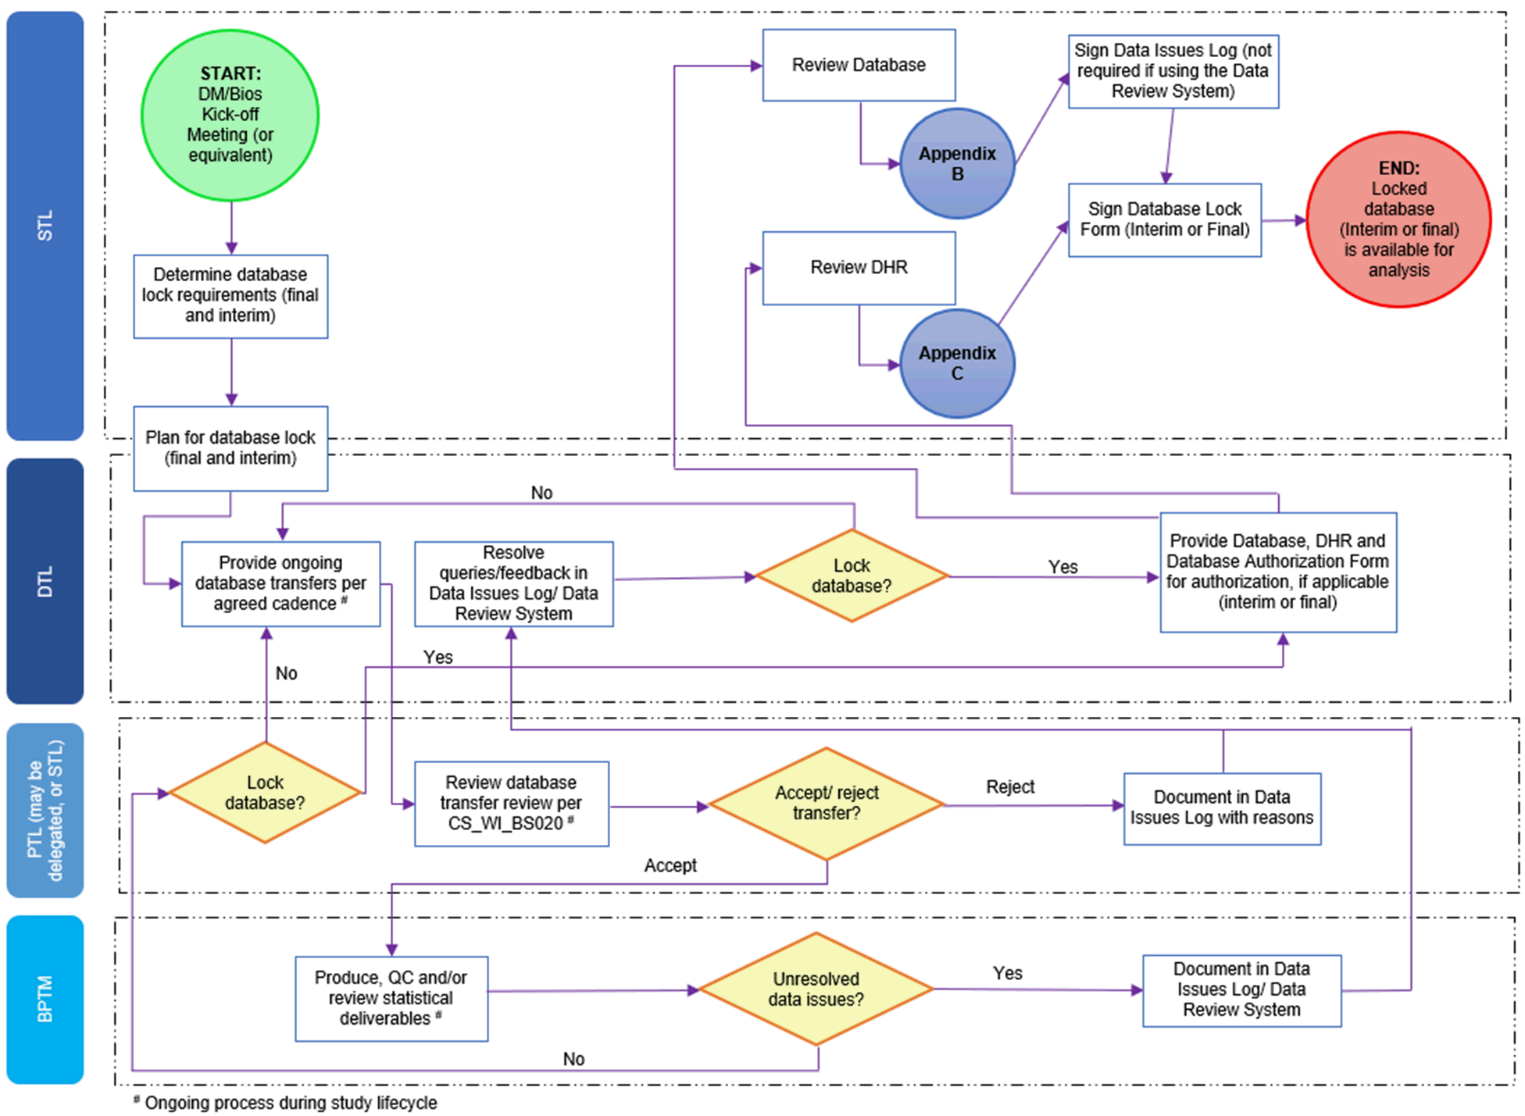

Appendix B: Statistical Review of the Database Workflow
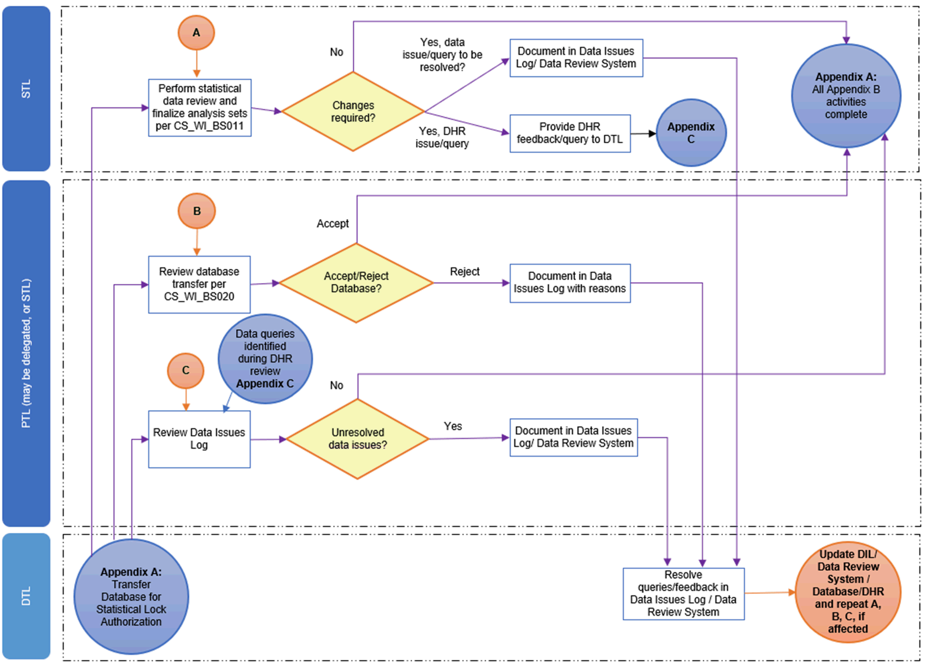

Appendix C: Statistical Review of the Data Handling Report
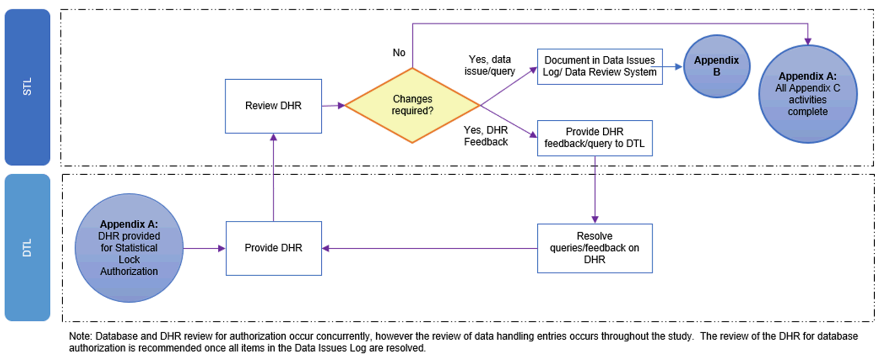

Page 11 of 11
Copyright © 1999, 2000, 2003, 2004, 2006, 2008, 2010, 2011, 2013, 2015, 2017, 2019, 2021, 2023 IQVIA. All rights reserved. The
contents of this document are confidential and proprietary to IQVIA Holdings Inc. and its subsidiaries. Unauthorized use, disclosure or reproduction is strictly prohibited.

Standard Operating Procedure Approval Signature(s)
This is a representation of an electronic record that was signed electronically in Content Server.
This page is the manifestation of the electronic signature(s) used in compliance with the organization’s electronic signature policies and procedures
Refer to Signatories CV for Business Title.

UserName: Ranjan, Santosh (q723916) Title:
Date: Tuesday, 28 February 2023, 10:32 AM Eastern Time Meaning: Signing this Document Indicates My Approval
================================================

UserName: Bickford, Emma (q637065) Title:
Date: Tuesday, 28 February 2023, 11:00 AM Eastern Time Meaning: Signing this Document Indicates My Approval
================================================

UserName: Morrow, Ellen (q405835) Title:
Date: Tuesday, 28 February 2023, 11:22 AM Eastern Time Meaning: Signing this Document Indicates My Approval
================================================

